Web Tech Lab Question 2

30th August 2024

Question:

Create an unordered list nested inside ordered list and apply the following:

* Insert an image of Main item on top right corner of web page.
* Display heading as Marquee. •
* Use different font styles and colors for different ordered list items.
* Insert Horizontal lines after each ordered item.

OUTPUT:

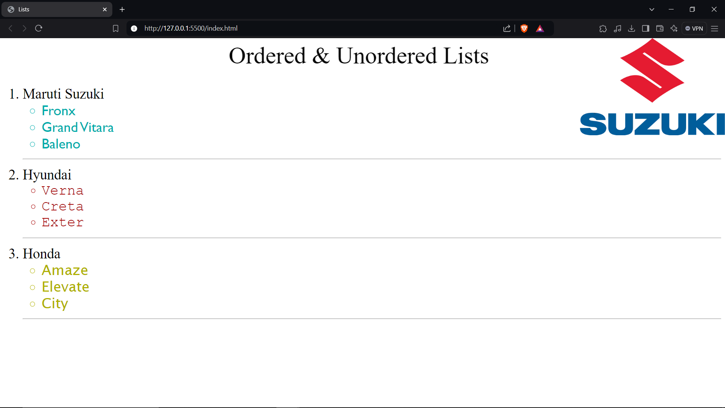

SOURCE CODE:

index.html

<!DOCTYPE html>

<html lang="en">

<head>

    <meta charset="UTF-8">

    <meta name="viewport" content="width=device-width, initial-scale=1.0">

    <title>Lists</title>

</head>

<body background="./Maruti Suzuki Logo.webp" style="background-repeat: no-repeat; background-position: top right; background-size: 20%;" >

    <marquee style="font-size:50px;">Ordered & Unordered Lists</marquee>

    <ol style="font-size:30px;">

        <li>Maruti Suzuki</li>

        <ul style="color: rgb(0, 172, 172); font-family:'Gill Sans';”>

            <li>Fronx</li>

            <li>Grand Vitara</li>

            <li>Baleno</li>

        </ul>

        <hr>

        <li>Hyundai</li>

        <ul style="color: rgb(165, 0, 0); font-family: 'Courier New';">

            <li>Verna</li>

            <li>Creta</li>

            <li>Exter</li>

        </ul>

        <hr>

        <li>Honda</li>

        <ul style="color: rgb(176, 176, 0); font-family: 'Lucida Sans';">

            <li>Amaze</li>

            <li>Elevate</li>

            <li>City</li>

        </ul>

        <hr>

    </ol>

</body>

</html>